Assignment -4

Python Programming

|  |  |
| --- | --- |
| Date | 29-10-2022 |
| Name | Dharshini Priya S |
| Team Id | PNT2022TMID43466 |
| Maximum Marks | 2 MARKS |

**Question 1:**

**Import the necessary libraries**

Solution:

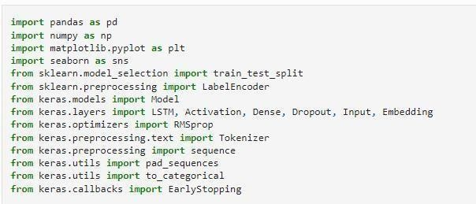

**Question2:**

**Download the Dataset**

Solution:

Dataset Downloaded and uploaded to drive [https://www.kaggle.com/code/kredy10/simple-lstm-for-](https://www.kaggle.com/code/kredy10/simple-lstm-for-text-classification/data) [text](https://www.kaggle.com/code/kredy10/simple-lstm-for-text-classification/data)classification/data

**Question3:**

**Read dataset and do pre-processing**

Solution:

Read dataset



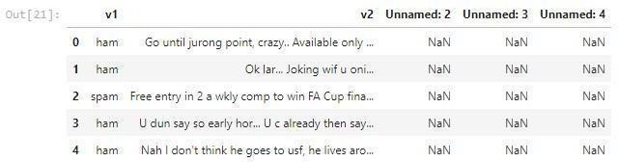

Pre-processing the Dataset

